REPORT – Strategy Learner (CS 7646)

by Paul Livesey
29/7/2018

Introduction
This Strategy Learner will use Decision Tree classification learner in the form of a Bag Learner as an effective trading strategy and to run experiments to prove this to be the case.
This report is broken down into two sections. The first section will examine the learner itself and the methods employed therein, including a detailed look at the indicators. The second section will analyse the two experiments which took place.

Section 1 – The Strategy Learner

Introduction
For this project, the strategy learner was build on top of a decision tree learner.
The Strategy Learner consists of two main function, the first, addEvidence, is used to train the learner and, the second, testPolicy, is used to test it.

Training using AddEvidence
The first thing the trainer does is to load up the price data for the relevant symbol (in this case JPM) and then it creates tables of the three indicators (SMA, EMA and Bollinger© Bands). The next step is to determine a threshold based on the given impact.
Once the above setting up is complete, the trainer will go through all of the prices within the date range (and inside the window) and for each it will add the relevant inicators for the price to the input and add then it will use the algorithm given in the Classification Trader Hints...
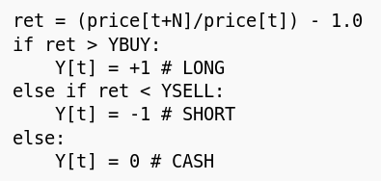

… to determine whether to buy, sell or do nothing, based on the prices.
Once all of the data is prepared, it is trained up using a previously prepared BagLearner algorithm.

Testing using testPolicy
Testing is a simple process which

Inidicators

Three indicators were used in the Strategy Learner:

- Simple Moving Average
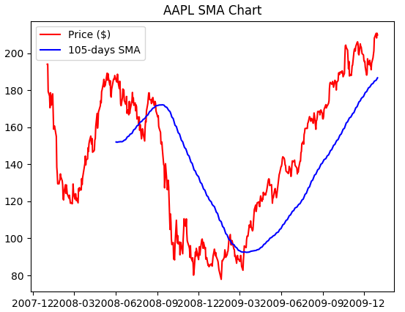

Simple Moving Averages takes the closing price data of an equity along with a window of a set number of days and for each after the window, calculates a daily rolling average of the closing prices in that window.

The chart for Apple shown above includes a blue line indicating the 105 day rolling average, which begins after 105 days from the start of the date range and then indicates the daily simple moving average.

The line flattens out the more volatile price line and lags behind by the specified number of days. It has been used in this strategy learner for two reasons:
- It is believed that this is a more accurate indicator of the real value and history of an equity than the price by itself and,
- Any time SMA line goes above the price line and then cuts back down and crosses back over it, this gives a strong indication that it is a good time to buy the given stock.

The Exponential Moving Average is an indicator which is similar to the Simple Moving Average

- Exponential Moving Average

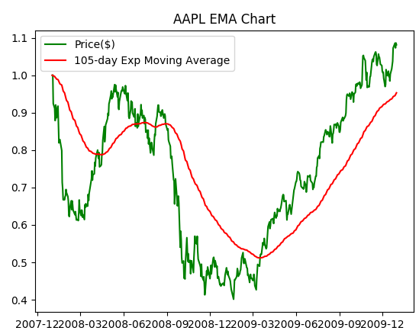

The Exponential Moving Average was used as the second indicator. This is a weighted average that is similar to the SMA, but it gives more import to the most recent price data by weighing it as such.

If the above chart is compared with the one from the SMA, it can be seen that any major variations in the price (e.g. sudden drops or rises) are not, smoothed at so much as in the SMA and are given more weight.

- Bollinger© Bands

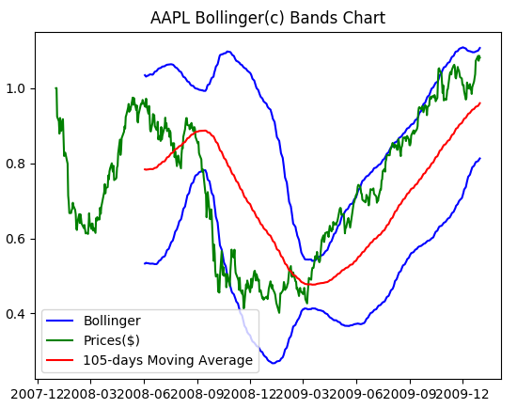

The final included indicator is the Bollinger Band. This indicator is another variation on the moving average. As can be seen on the above chart, four lines are normally given, the price (green) , the moving average (red) and then a top and bottom Bollinger Band (blue).

The Bollinger Bands themselves are above and below the average line by a certain number of deviations (usually 2) from the price. They therefore indicate the volatility of the equity, moving closer to the average when the price is less volatile, and further away when more volatile.

The may aim of the bands is to be able to compare them with the price to determine whether they are relatively too high or too low.

The bands are typically charted over a window of 20 days (the 105 above is used for illustration), although this can vary.

Experiment 1

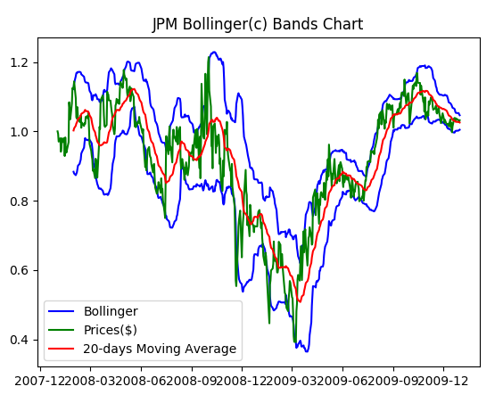

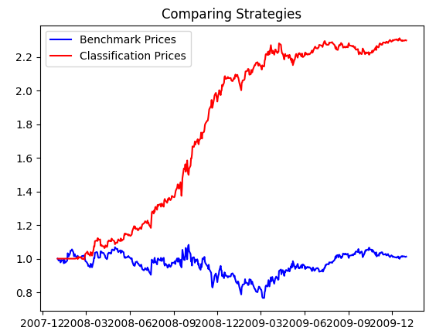

 | Benchmark Strategy | Classification Strategy
Cumulative Return
Mean of daily prices | 0.97 | 1.50
Max daily price | 1.08 | 1.85
Mean of Daily Returns
Standard Deviation of Daily Returns
Final Portfolio Value

The initial experiment was to compare the results of the Strategy Learner with a specified benchmark. The benchmark was simply be to begin with $1,000,000 at the start date and keep the rest in cash.

To achieve the results presented, simple run the experiment1.py program. The scores are normalized.

Although it is often believed that there is no information in the price day, this experiment show that the opposite is very much true.

